Assignment 03

Name: Sarthak Niranjan Kulkarni

Roll No.: T211075

Div: A

Aim: Assignment to understand and create an application in Salesforce using Apex programming language.

Steps:

Open your browser and search for salesforce trailhead

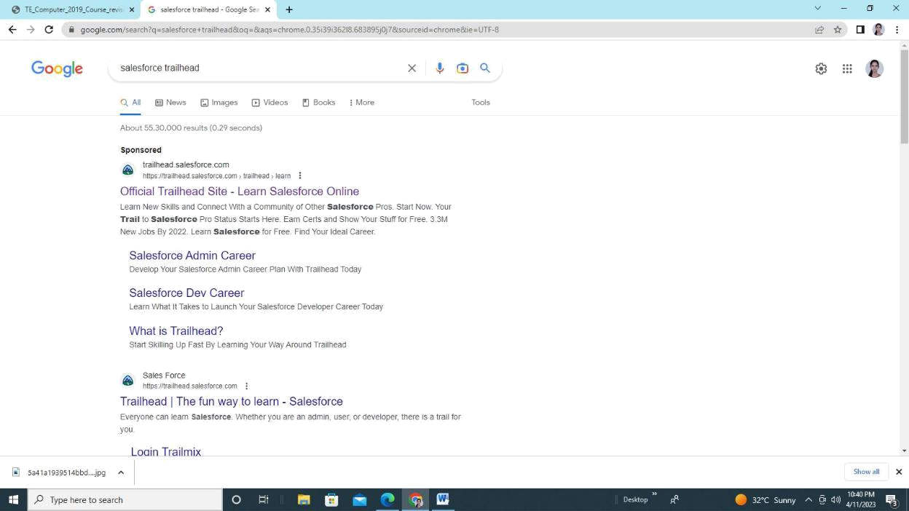

Click on profile and select “Hands On Orgs”.

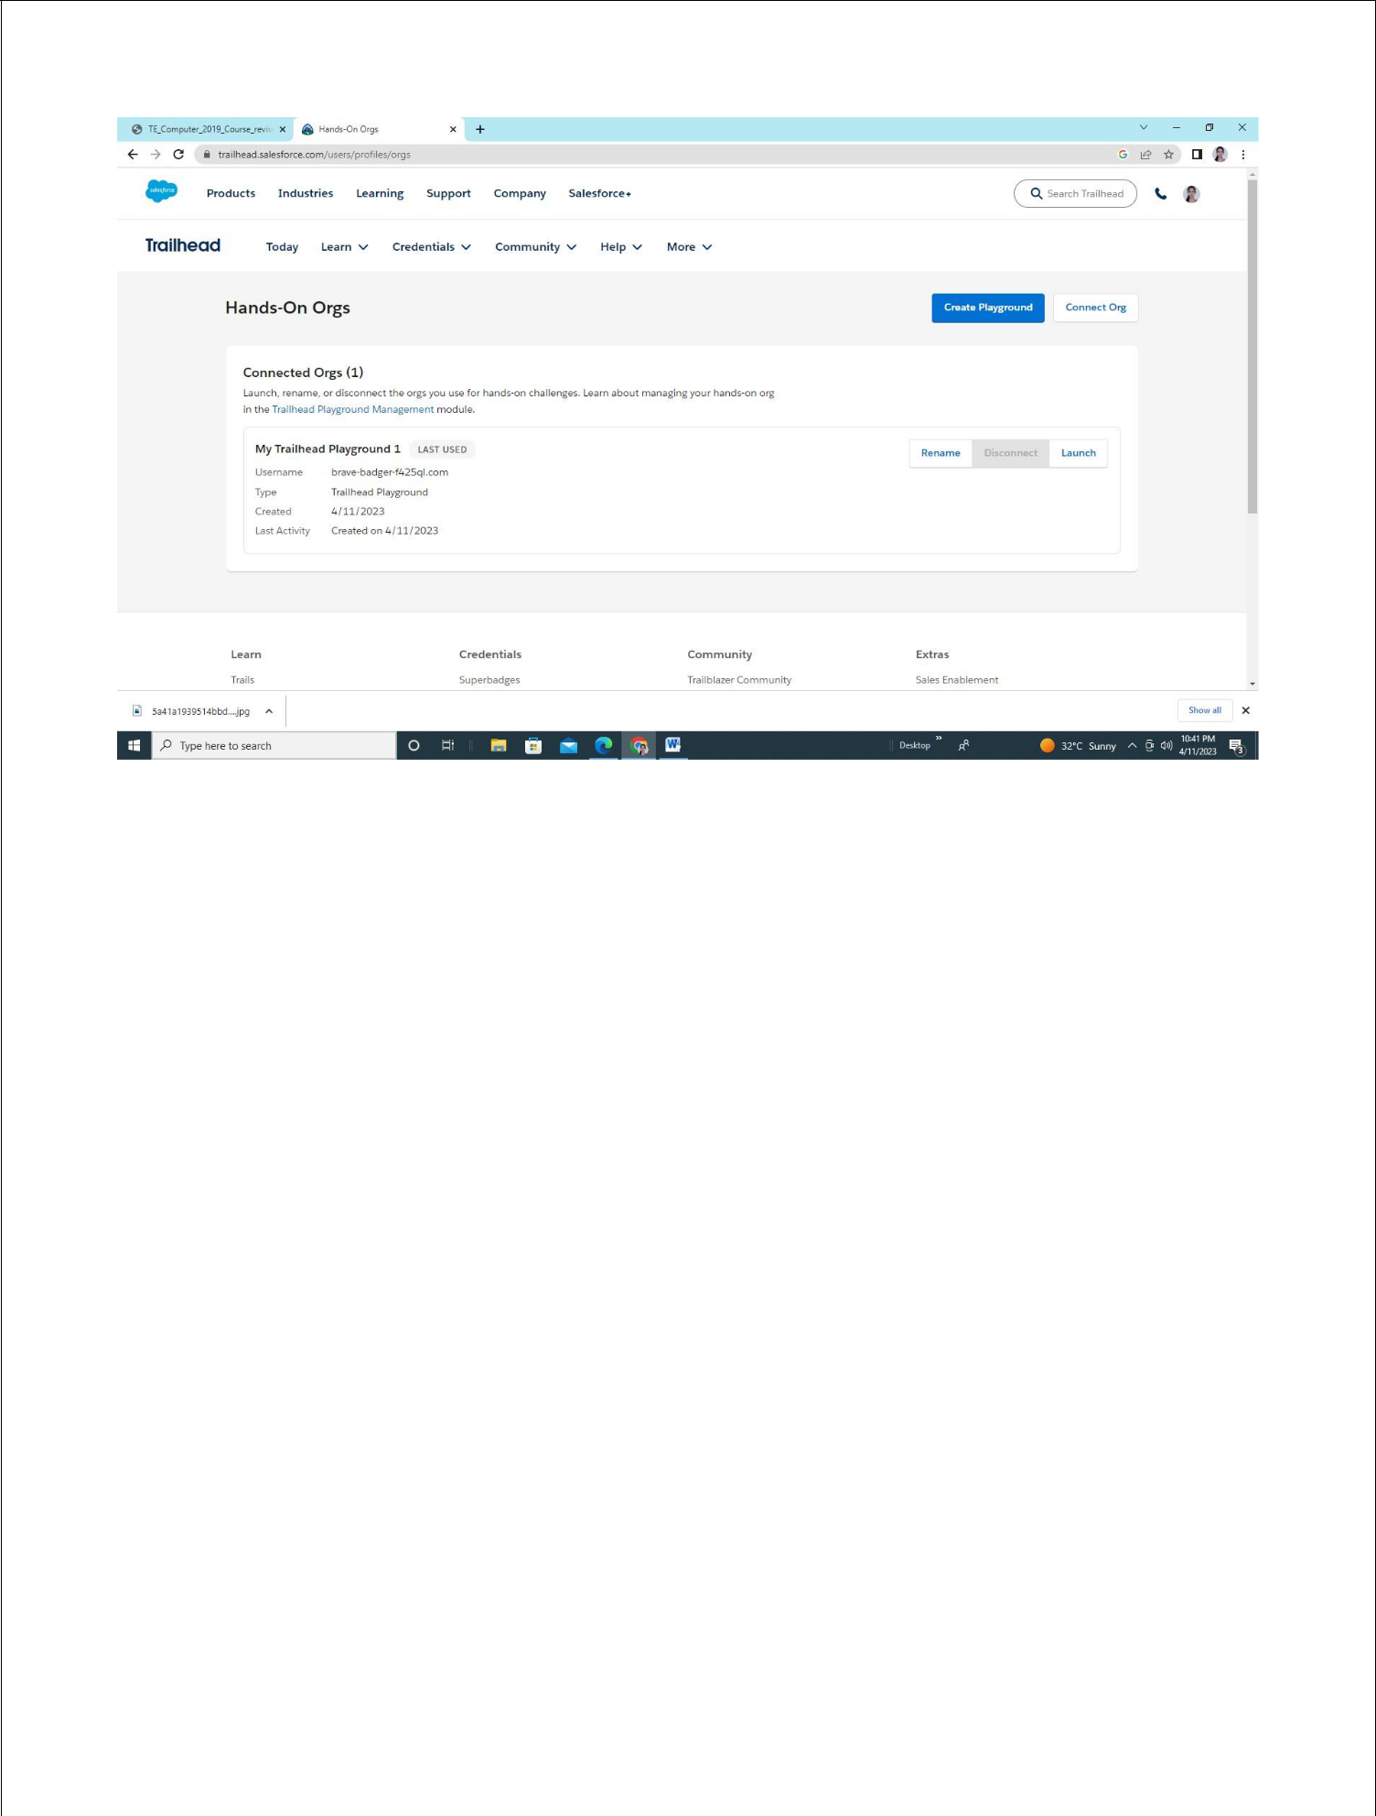

Click on Launch

Click on developer console

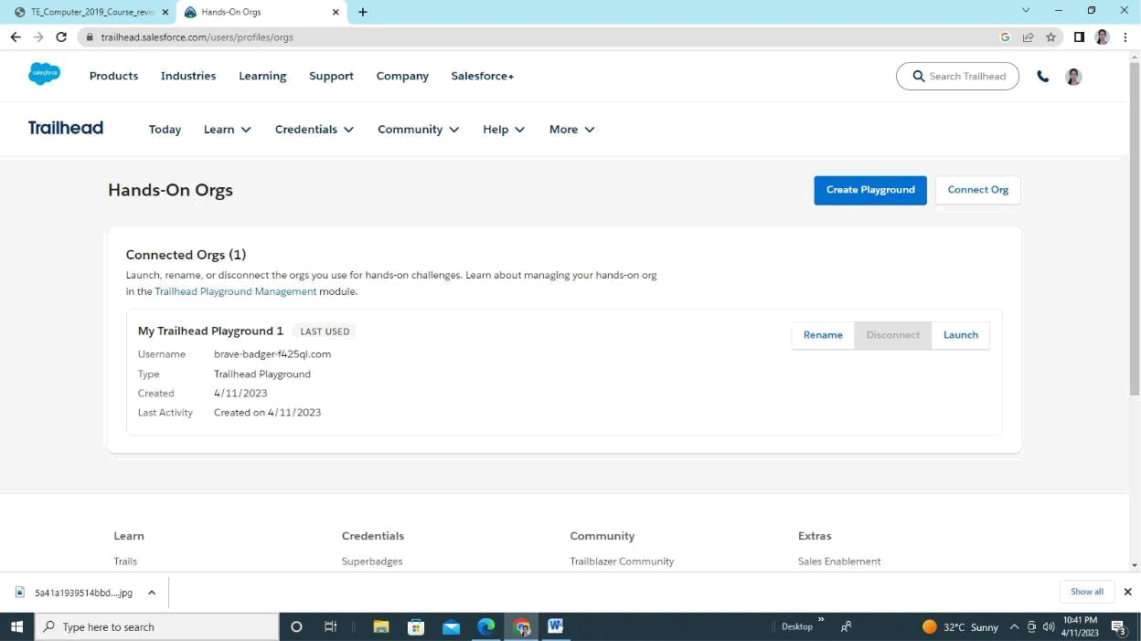
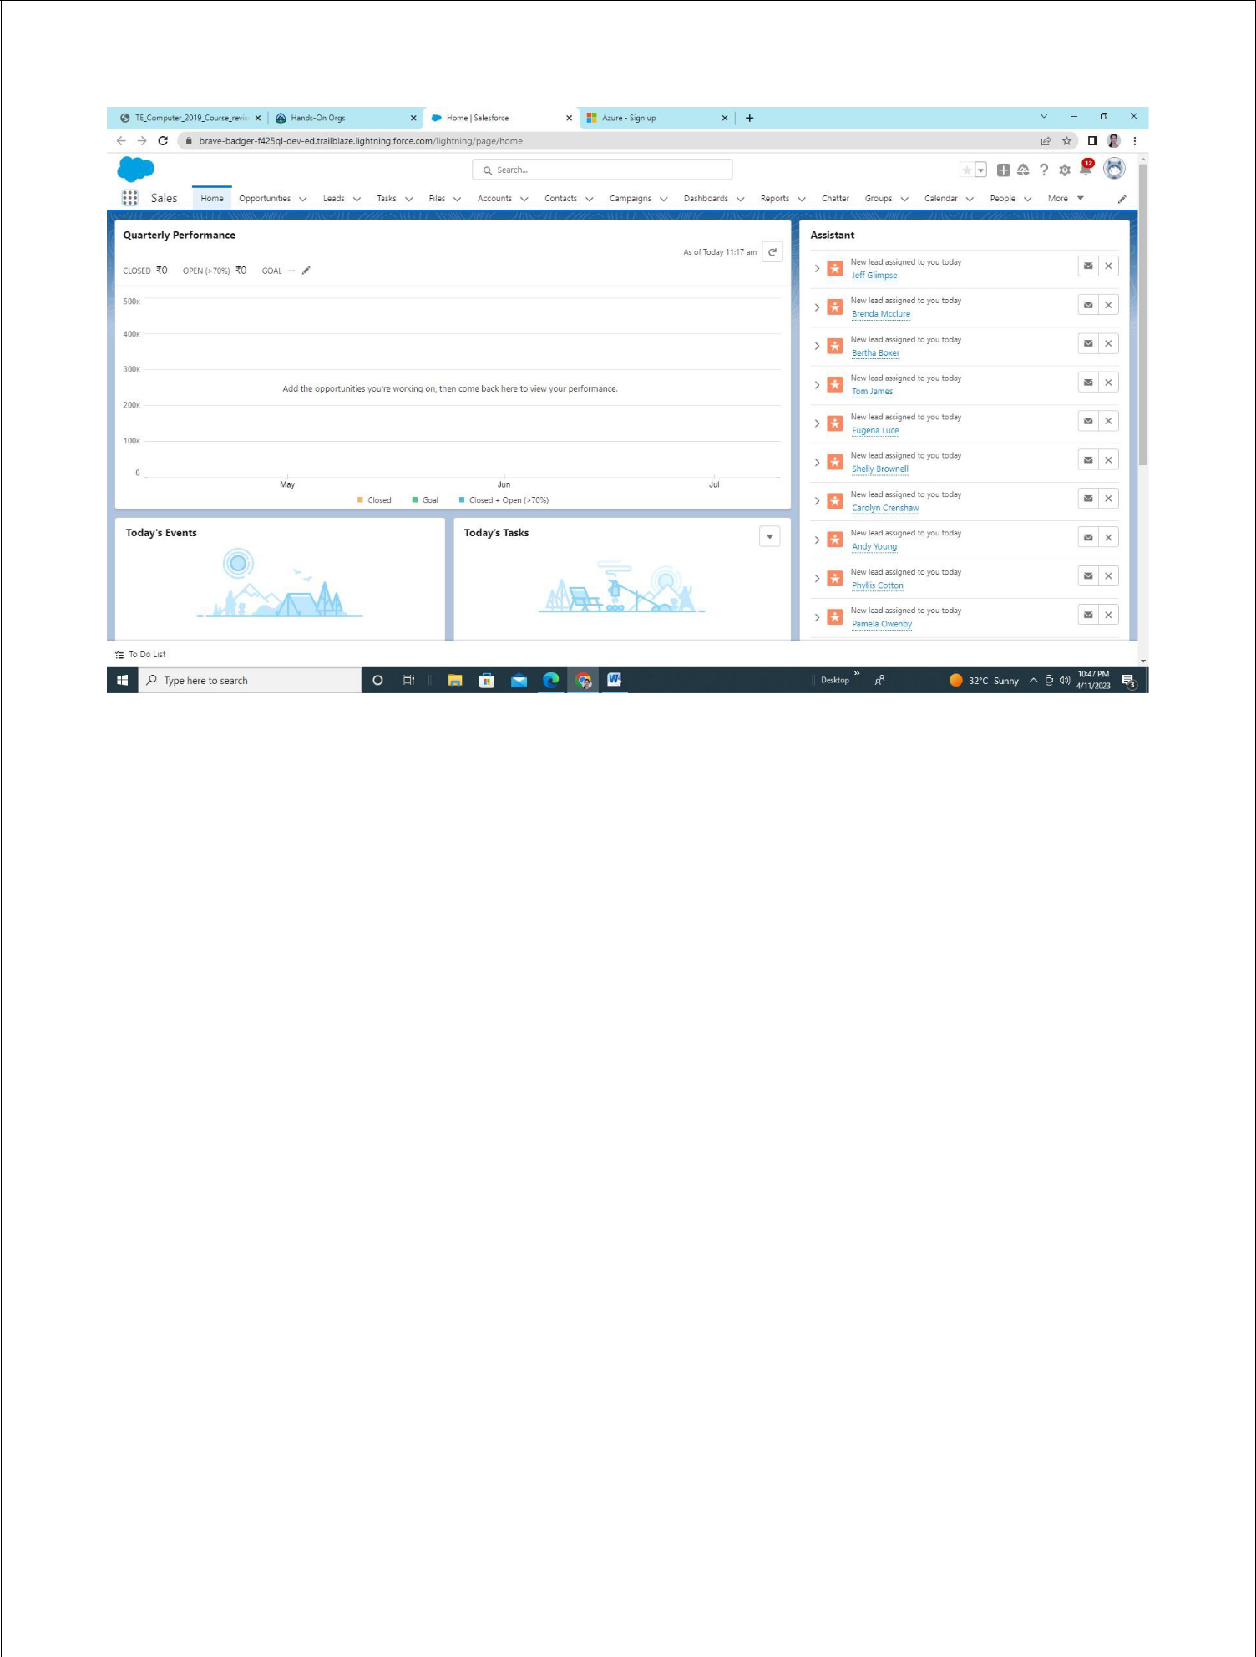

Select file name ->New->apex class

Enter class name Then click OK

In Body of created class write the following method

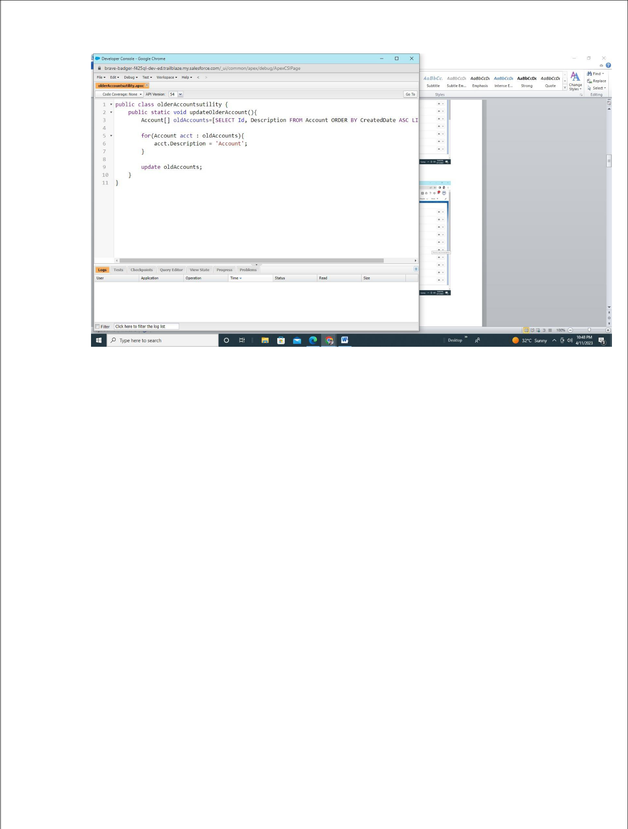

Select File Menu and save file
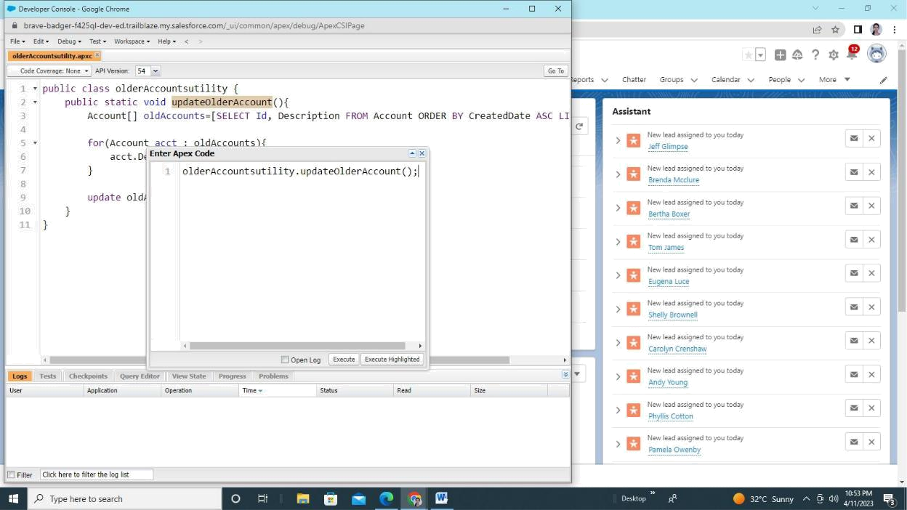

Click debug menu and select open execute anonymous windowAdd above apex code in open window and click on Execute select setting option and click on setup

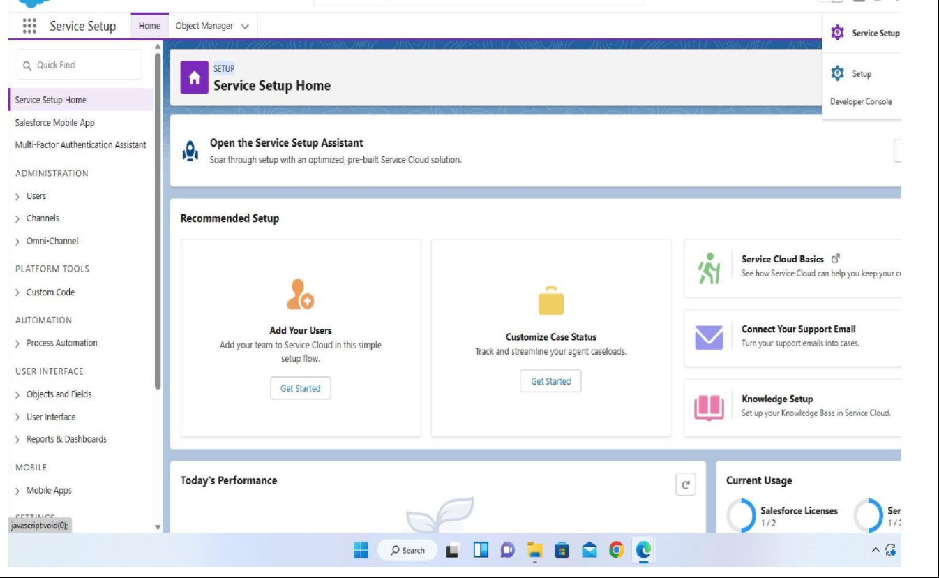

In your Trailhead Playground, select all apps then click

On sales Select the accounts tab and click on recently viewed

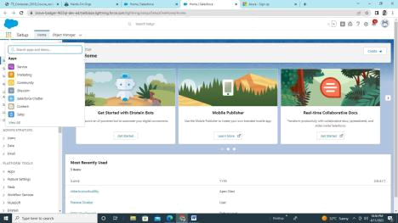

Click on recently folder

Click on details

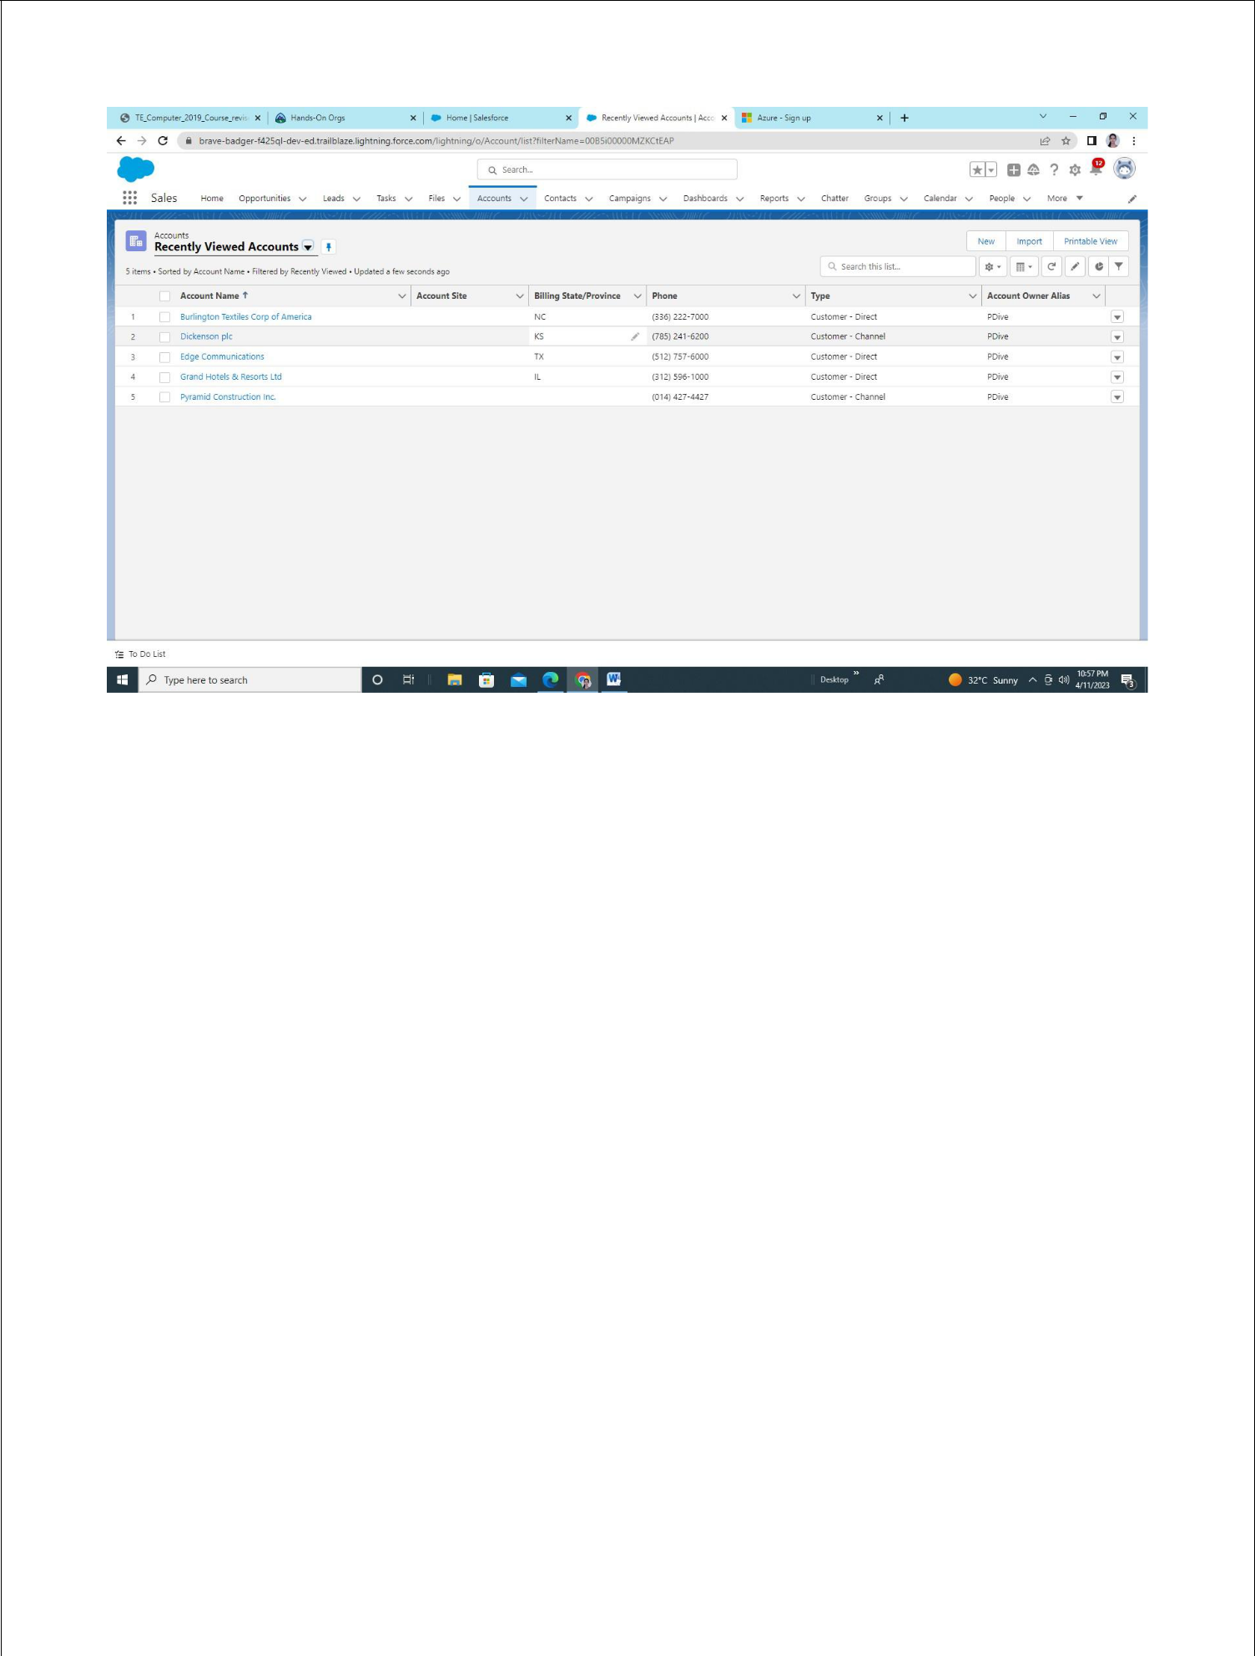

See the Output in Description
